BMW Sales Performance Report

1. Executive Summary (Top-Level Takeaway)
The BMW business is primarily driven by its premium models, with the 7 Series being the top revenue generator. While sales were highest in 2022, there is a clear drop-off in December compared to the peak in September. Regional markets are very balanced in terms of sales volume, but colour preferences vary significantly by geography. Our most profitable segment overall is the High Sales Classification.

2. Objective / Business Question
The main goal of this analysis is to identify which models and sales categories bring in the most money, understand when our peak and low sales periods occur, and discover what product features (like colour and transmission) customers prefer across our different regions.

3. Key Metrics / KPIs
We analysed the following key numbers:
- Sum of Revenue: The total money brought in by each model and sales group.
- Sum of Sales Volume: The total number of vehicles sold, used to track performance by year, month, and region.
- Average of Price (USD): The average selling price of vehicles broken down by fuel type.
- Sales Classification: A comparison of revenue from our High and Low sales groups.

4. Insights & Findings
Insight 1: Our High-End Products Bring in the Most Money
- What We Found (Fact): The High Sales Classification generated over 9.7 trillion in revenue, which is about 409 billion more than the Low Classification group. The 7 Series is the single highest-grossing model by revenue.
- Why It Matters (Interpretation): Our biggest financial returns come from the most expensive cars. We must prioritize the production and marketing of our high-end models.
- Possible Action (Recommendation): Focus advertising efforts and new feature announcements on the 7 Series, 3 Series, and i8 to maintain and grow sales in this highly profitable segment.
Insight 2: Sales Volume Follows a Strong Calendar Pattern
- What We Found (Fact): Sales volume consistently peaks in September ( 21,685,214) and is lowest in December (20,640,931). The highest yearly sales volume on record was in 2022 (17,920,946).
- Why It Matters (Interpretation): We can accurately predict our busiest and slowest periods. The dip in December, which is a major holiday month, is a missed opportunity for strong sales.
- Possible Action (Recommendation): Increase inventory and staff for the September rush. Introduce special year-end deals or incentives (like holiday financing offers) in December to prevent the usual sales drop.
Insight 3: Buyers Show a Slight Preference for Manual Transmission and the Colour Red
- What We Found (Fact): More cars were sold with a Manual transmission (127,362,077) than an Automatic (126,013,657). The most popular colour chosen across all regions is Red (42,750,183).
- Why It Matters (Interpretation): We should not ignore the demand for manual transmissions, as a dedicated group of buyers still prefers them. We must ensure we have plenty of popular colours like Red and Silver in stock.
- Possible Action (Recommendation): Ensure the popular Red colour is available for high-volume regional sellers, and promote the availability of Manual transmission models to appeal to performance.

5. Supporting Visuals
Here are three key tables showing the numbers behind the insights:
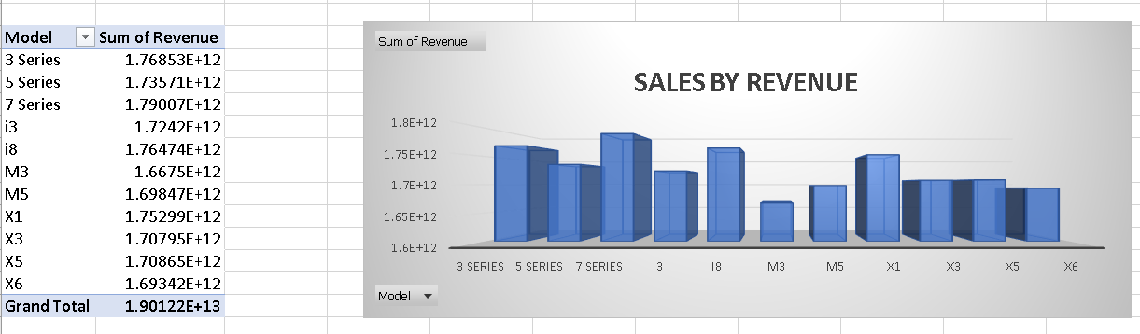
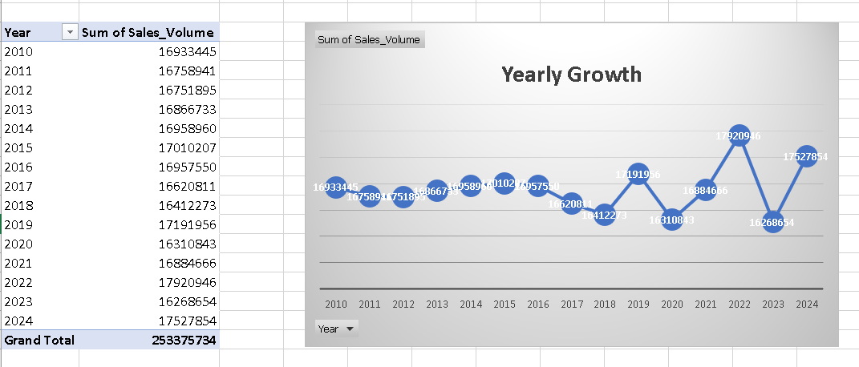

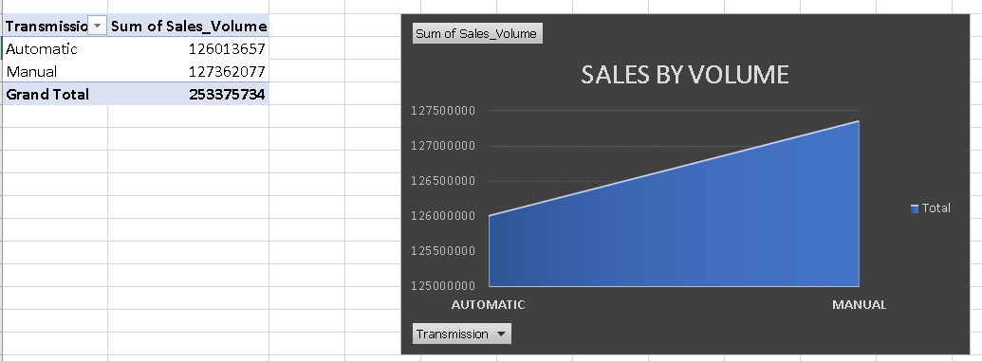

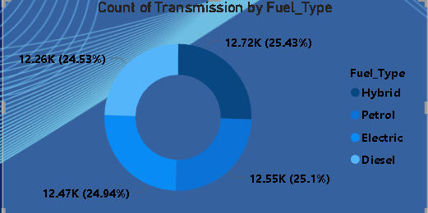

6. Limitations
This report is based on total revenue and sales volume. We were unable to calculate the actual profit margins because the Cost of Goods Sold (COGS) data was not included. Therefore, while the 7 Series brings in the most money, it may not necessarily be the most profitable model.

7. Next Steps / Recommendations
- Run a Profitability Study: We need to get the COGS data to confirm if the 7 Series is truly the best model for the company's bottom line.
- Localize Colour Inventory: The purchasing team should work with regional sales teams to ensure inventory matches local colour demand (e.g., Africa prefers Grey, Asia prefers Black, North America prefers Silver).
- Capitalize on Price Data: Since Electric vehicles have the lowest average price among all fuel types, consider strategically raising the average price of electric vehicles through premium features or packages to close the price gap with Hybrid and Diesel models.

